**May 16, 2023**

**Name: UMUHUZA AIME**

**ID:22215**

**COURSE TITLE: WEB TECHNOLOGY & INTERNET**

**COURSE CODE:**

**LECTURER: Jerome N. RWEGO**

**Final Exam**

**Project title: Scheduling Performers Management System**

1. **Project Requirements**

**Scheduling Performers Managements System,** is a system designed to effectively manage and coordinate the scheduling of performers for various music events or performances.

It provides a comprehensive platform that streamlines the entire process of performer scheduling, ensuring efficient organization and communication between event organizers and performers.

Key features and functionalities of the system:

**Performer Database:** the system maintains a centralized database containing detailed information about performers. This includes their names, email, genres, availability or time he/she will perform.

**Event Scheduling:** the system offers a user-friendly interface to manage performances. Event organizers can define event details such as date, time, duration, and venue. They can also select performers from the database and assign them to specific slots or stages within the event schedule.

**Availability Management:** The admin can update the performer availability within the system, indicating their preferred time slots, blackout date, or conflicts. This allows event organizers to schedule performers effectively and avoid double bookings or scheduling conflicts.

**Conflicts Resolution:** The system assists in identifying and resolving scheduling conflicts that may arise due to overlapping performers or unforeseen circumstances.

1. **Project Plan:**

This project is mainly focus from contacting the artist performer until the end of the performance.

Here is the channel: we shall contact the Music artist through email sending him/her the details of the event attached with the contract. If he confirms to be with us in the event, we shall receive confirmation through our email attached with a signed contract; now we’ll schedule the start time and end time of his/her performance according to the event timeline.

1. **Database Schema**

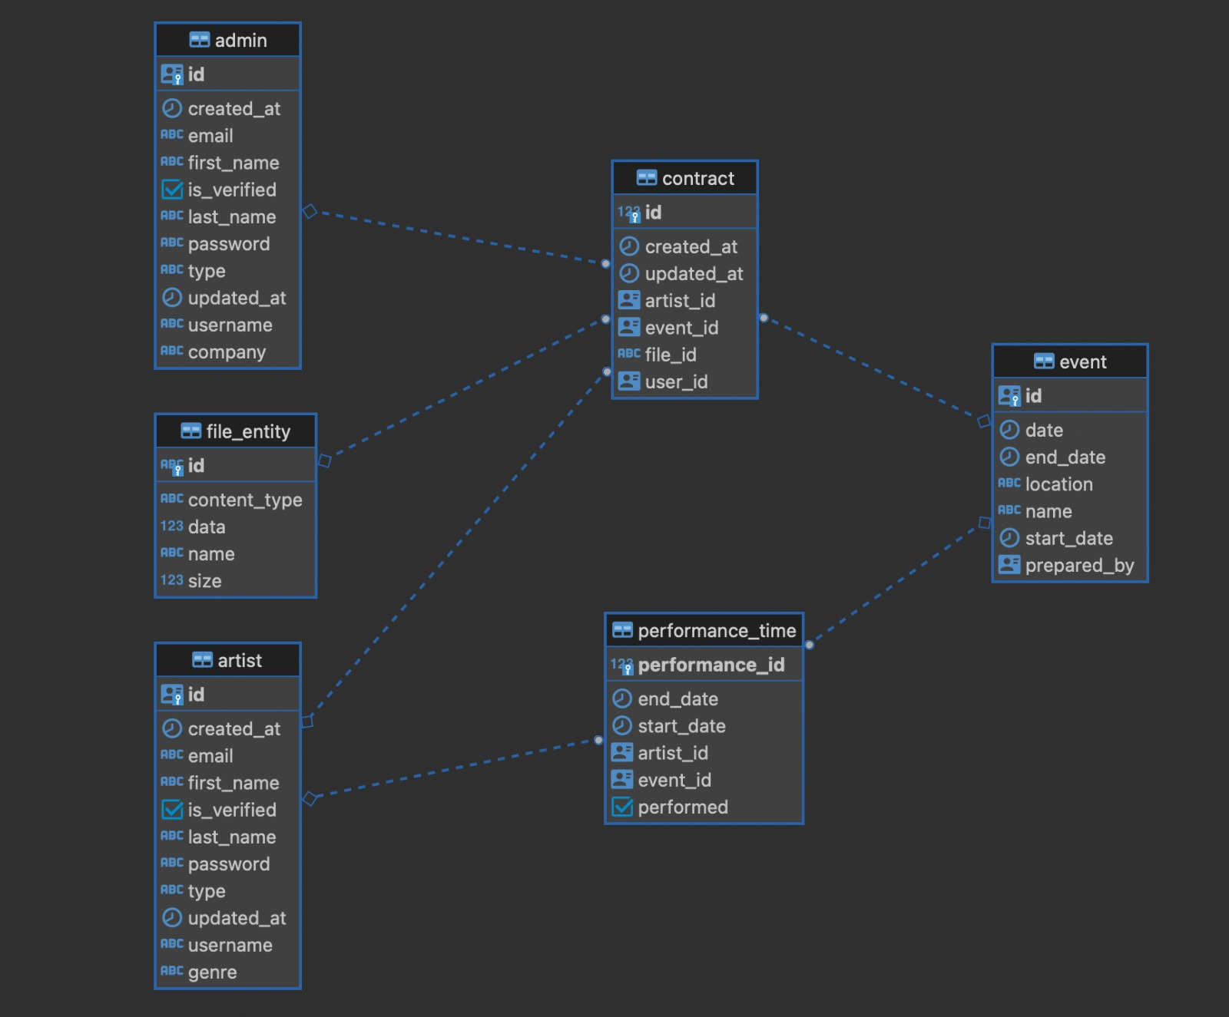

1. **User Documentation**

**Functional and non-functional requirements of my system.**

**Functional Requirements:**

**User Registration and Authentication:** Users should be able to register and authenticate themselves to access the system.

**Performer Management**: The system allows the creation, modification, and deletion of performer profiles, including details such as names, contact information, genres, availability.

**Event Creation and Management:** System admin should be able to create events, specify event details (date, time, venue), and assign performers to specific time slots or stages within the event.

**Availability Tracking:** System should be able to update the availability, indicating preferred time slots, blackout dates, or conflicts.

**Conflict Resolution:** The system should identify and resolve scheduling conflicts, such as overlapping performances or conflicting availability, and provide suitable alternatives or solutions.

**Non-Functional Requirements:**

**Usability:** The system should have an intuitive and user-friendly interface, making it easy for users to navigate, schedule performers, and manage events.

**Performance:** The system should be able to handle a large number of performers and events efficiently, with minimal delays or performance issues.

**Security:** The system should implement appropriate security measures to protect user data and ensure secure access to the system.

**Reliability:** The system should be reliable, ensuring that performer schedules are accurately maintained and that notifications are delivered promptly.

**Scalability:** The system should be designed to handle future growth and accommodate increasing numbers of performers, events, and users.

Compatibility: The system should be compatible with various devices, browsers, and operating systems, allowing users to access and use it from different platforms.

**Data Backup and Recovery:** The system should include mechanisms for regular data backups and a recovery plan in case of data loss or system failure.

**Login form:**

User name, password

**Registration form:**

First Name, Last Name, E-mail, Username, password

**Event form**

Name, location date, Start Date, End Date

How to navigate the application:

We navigate our project through the dashboard

**Technical Documentation:**

**System Development:** Designing and developing the software system to handle performer scheduling, database management, event creation, availability tracking, conflict resolution, communication, and reporting.

**Database Management:** Creating and maintaining a centralized database to store and manage performer information, including names, contact details, genres, availability, performance history, and technical requirements.

**Event Scheduling:** Building features to allow event organizers to create, manage, and schedule events or performances. This includes defining event details, assigning performers to specific time slots or stages, and managing event-related information.